Former United States Chess Champion GM Larry Christiansen will be giving a 90 minute lecture via Skype on Friday, March 15, 2013, in the Geffen Auditorium, Gonda Building Mayo Clinic, Rochester, MN. Doors open at 7:00 p.m. with the lecture beginning at 7:30. Admission is FREE to RCC Members and $10.00 to non-members.

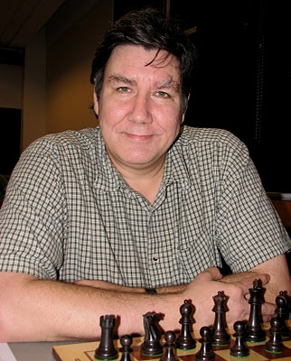
Larry Christiansen grew up in Riverside, California and joined the Riverside Chess Club in 1967. He became a master in 1971, won the 1971 National High School Championship that same year and repeated that success in 1972 and 73.

Larry won the US Junior Championship 1973-75 and represented the US in the World Junior Championship twice in Teeside 1973 (3rd) and Tjientiste, Yugoslavia (2nd). In 1977 Christiansen became a Grandmaster, becoming one of the few players (including Mikhail Tal) to go directly from Master to Grandmaster without holding the intermediate title of International Master.

In 1978 Christiansen left college to work for the Church's Fried Chicken Corp. as their chess goodwill ambassador. He traveled across the US and Canada giving lectures and simultaneous exhibitions .

In 1980 Larry shared the title of US Champion with Walter Browne and Larry Evans and repeated that success in 1983. Larry came close to capturing the title all through the 1980s and 1990s until he won it clear in 2002 ahead of Nick de Firmian.

Larry has represented the USA in 11 Chess Olympiads and has won over 25 international tournaments including Torremolinos 1977, LInares 1979, LInares 1981 (with Karpov), Munich 1991, Reykjavik 1998, and Merida 1998.

In 1990 Larry married his wife Natasha. They moved to Germany that same year where Larry was a member of the powerful German chess team from Porz. He also competed in the Swiss chess league from 1992-1996.

He currently lives in Cambridge, Massachusetts with Natasha where he teaches chess and is active in the US Chess League with occasional tournaments.

For more information, contact: Mike McKinley Prez25@live.com 507-254-1126
Dennis Mays dennis_mays@q.com 507-254-6809
http://rochesterchess.com/ and http://www.facebook.com/RochesterChess

